Final Paper – ARH 358

Jared Galloway

Utensils for Sustainability

The utensils we use to eat play a key role in our everyday lives. In the late 1600s and early 1700s, when disease was a major problem in Europe, the use of utensils became much more necessary. The plague inspired many to purchase multiple sets of utensils for their homes in pursuit of avoiding touching food with their hands. While much of disease related to the food we eat has been eliminated, today, a problem outside disease threatens our way of life; trash. At first, Utensils were used as a means of avoiding getting sick, here I describe utensils as a means of avoiding waste and promoting sustainability.

For my designed object, I have chosen a set of disposable utensils seen in Figure 1. The functionality of this set of cutlery is advertised to be economical, and disposable. Meaning they are cheap and can be thrown away with ease. The design of this object was likely inspired by metal cutlery for which I have chosen to look at mid 18th century silverware seen in Figure 2.

For centuries, the church looked down upon the use of forks and even went as far as to state “God in his wisdom has provided man with natural forks—his fingers. Therefore, it is an insult to him to substitute artificial forks for them when eating.” (Ward). While this argument hold much less friction today, we have come to realize a much more real problem with utensils in the world of convenience. Disposable plates, forks, bags, tin foil and any container that would be thrown away directly after being used is a direct insult the world we live in. Even though some of these items are able to be recycled, it’s hard to tell how effective the recycling is. In the future, as sustainability becomes more prominent, restaurants will begin to offer a “no – trash” option which allows customers to bring their own container for food. This idea is similar to how people are beginning to bring their own coffee cups instead of using disposable ones.

In response to this, I suggest a useful, practical container which is easily cleaned and can be carried in a bag without obstructing of other things within the bag (Figure 3). This container can be easily folded to be transported and will be insulted to keep the contents cold/warm for longer. While Tupperware exists, its purpose is more centered towards keeping left-overs in home. This new product will be created for transportation, and be made to fold so it is compact when not being used. Our product will be easily cleaned with new material technology which allows absolutely no stick; meaning it can be cleaned virtually anywhere. It will include everything the user needs for eating meals that are solid and/or liquid like soup. With high quality coffee cups like hydro-flask, users get to personalize their containers, keep their drinks hot, and save the environment from a disposable coffee cup each time they get coffee. The idea of our new product is very similar; It will be high quality, personal, and help the environment. Furthermore, there could be stations which offered streamlined cleaning. The user would simply connect two ports to their container, and a powered machine would power wash the entire container and utensils in merely seconds.

My design look to a time before injection molding and other industrial techniques allowed for the mass production of disposable Items. Rather, we should produce items that will be re-used for years and looked upon as belongings that we can gain a personal connection with.

References

1. Ward, Chad. “Origins of the Common Fork.” *Leite's Culinaria*, Leite's Culinaria, 18 Aug. 2017, leitesculinaria.com/1157/writings-origins-fork.html.
2. Needham (2000). *Science and Civilisation in China. Volume 6: Biology and biological technology. Part V: Fermentations and food science.* Cambridge University Press. Pages 105–110.
3. Wilson, Bee. Consider the Fork: A History of How We Cook and Eat. New York: Basic, 2012. Print.

(Figure 1) Plastic set of cutlery

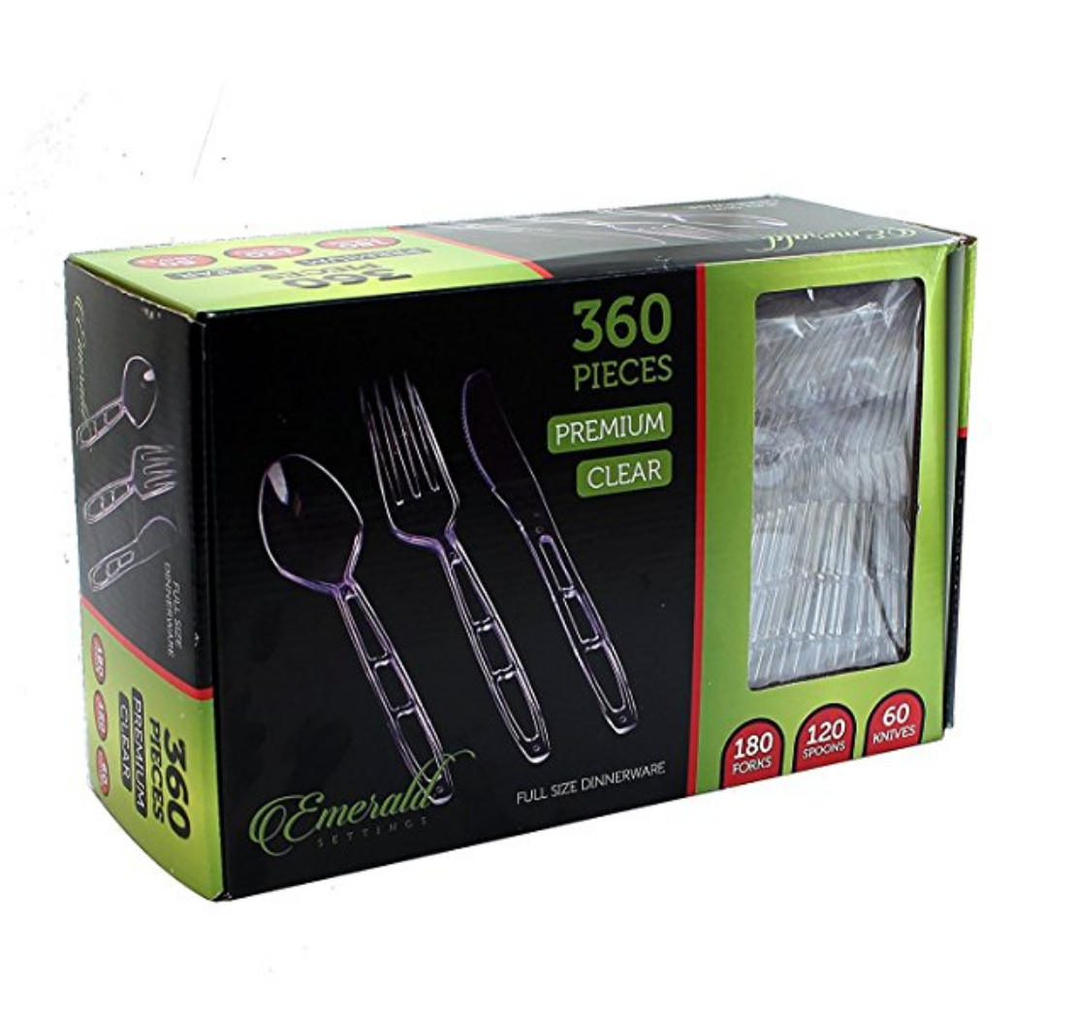

(Figure 2) Mid 18th century silverware <https://www.mfordcreech.com/Set_6_Early_George_III_Acanthus-Cast_Silver_Teaspoons.html>

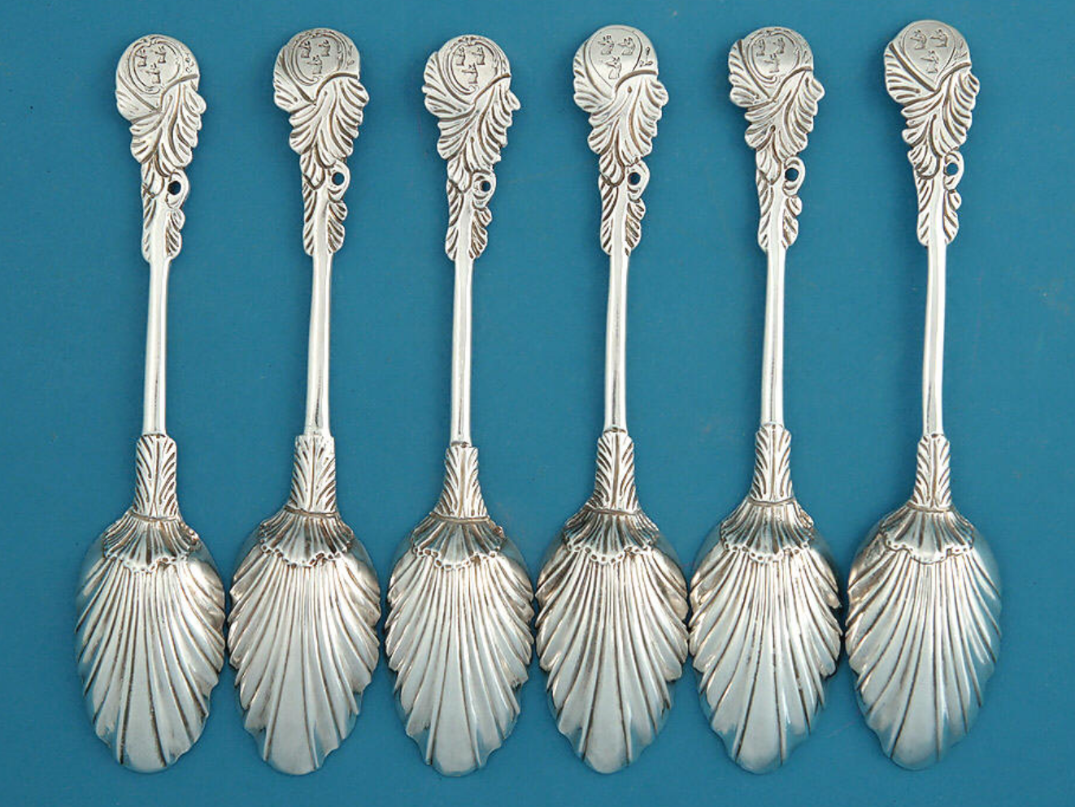

(Figure 3) Re-usable food container:

